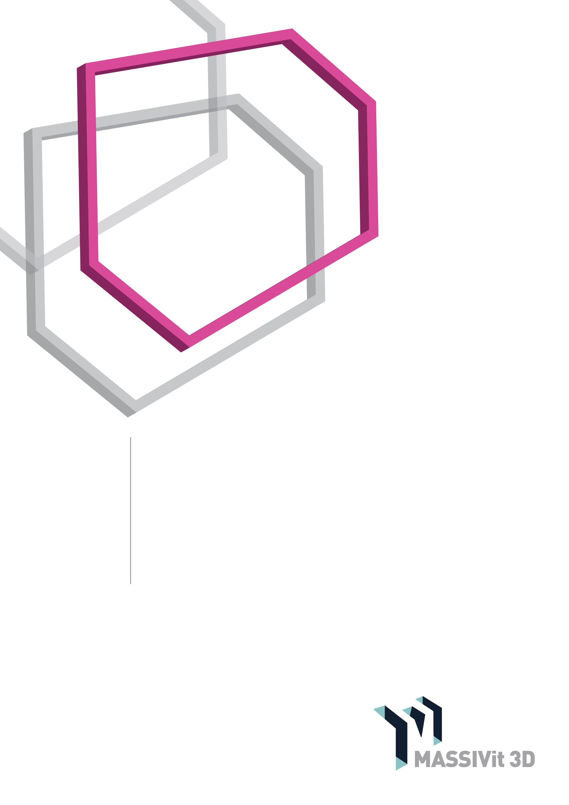

Massivit

HOW-TO GUIDE

Projection Mapping on Massivit 3D Prints Using Madmapper

[www.massivit.com](http://www.massivit.com)

The information provided in this document is believed to be accurate and reliable. However, no responsibility is assumed by MASSIVit 3D for the use of this document or for the performance of any materials mentioned. MASSIVit 3D reserves the right to make changes to this document or any material included in it at any time and without notice.

Published in August 2018

© Copyright MASSIVit 3D 2018

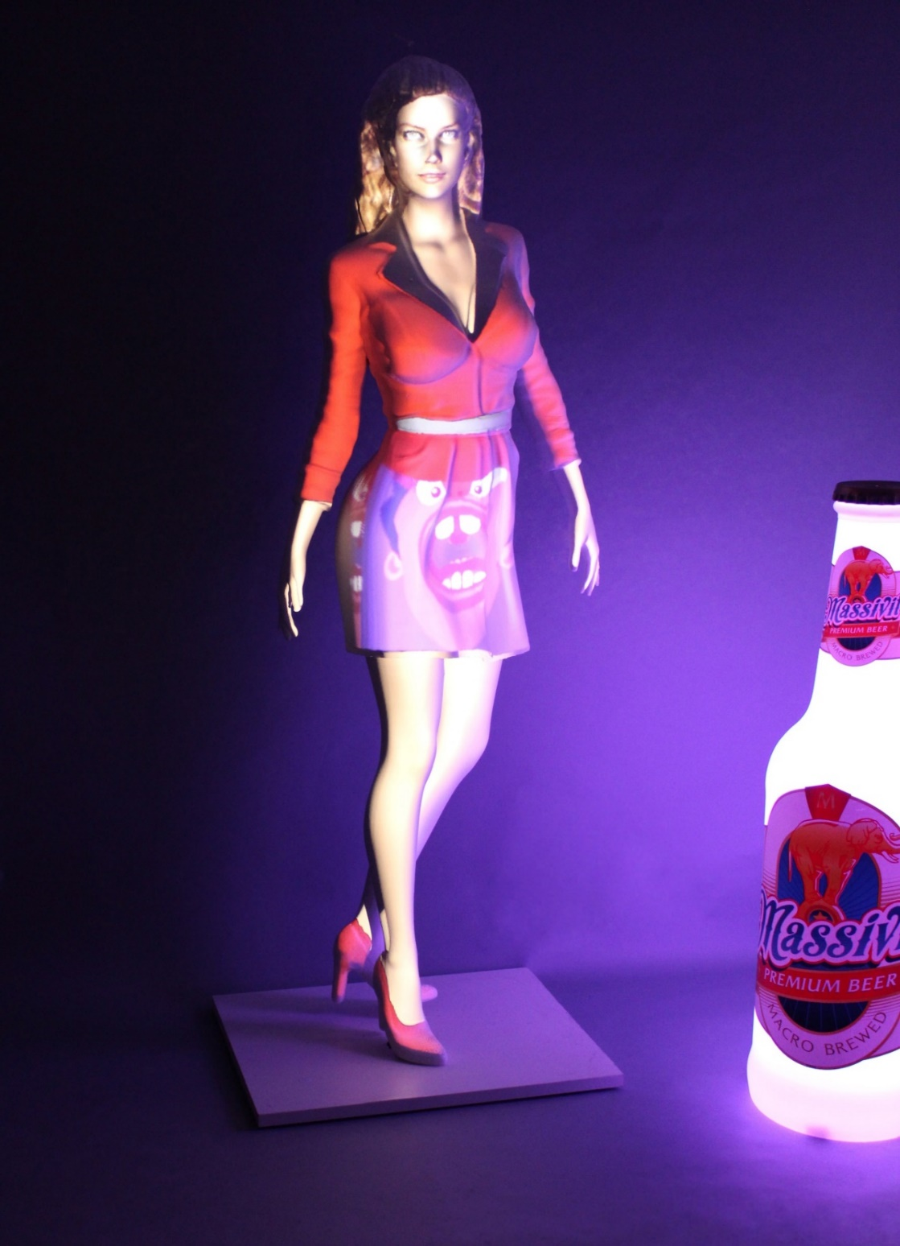

TABLE OF CONTENTS

Introduction 5

Create the design 7

Step 1: Create a low-polygon-count version of the 3D Model 7

Step 2: Use UV maps as a positioning guide 8

Step 3: Edit the video 10

Step 4: Import 3D models and video texture into *Madmapper* 11

Step 5: Create a projection 13

Step 6: Set up the projection, prior to calibration 13

Step 7: Projection Mapping Calibration 14

Step 8: Apply the video texture & adding effects 16

Workflow Summary 18

Introduction

Projection mapping can be a great solution for adding texture, color and motion to your 3D displays. The advantage of printing in 3D for this purpose lies in the fact that UV maps are created from the original 3D file. When the Massivit 3D print is done, the projection mapping process is ready to go in a matter of a few simple steps.

The combination of Massivit 3D printers and Madmapper software offers a simple solution for creating complex eye-popping displays with endless possibilities.

Video mapping is an innovative method of projecting a video movie on a 3D object with a great deal of precision. The method uses the 3D information used for printing to project an image onto that printed shape. The difficulty associated with Video Mapping arises when trying to perfectly align a 2D movie on a 3D object. This problem is aggravated further when the 3D object is more complex, where it may be almost impossible to have any alignment take place.

To address this issue, a 3D object that was generated and printed digitally is a perfect solution, since you have its digital information, for calculating the inherent distortion, and can achieve perfect alignment between the video and the 3D print.

This step-by-step guide will help you to create your own video mapping.

### Software and hardware required

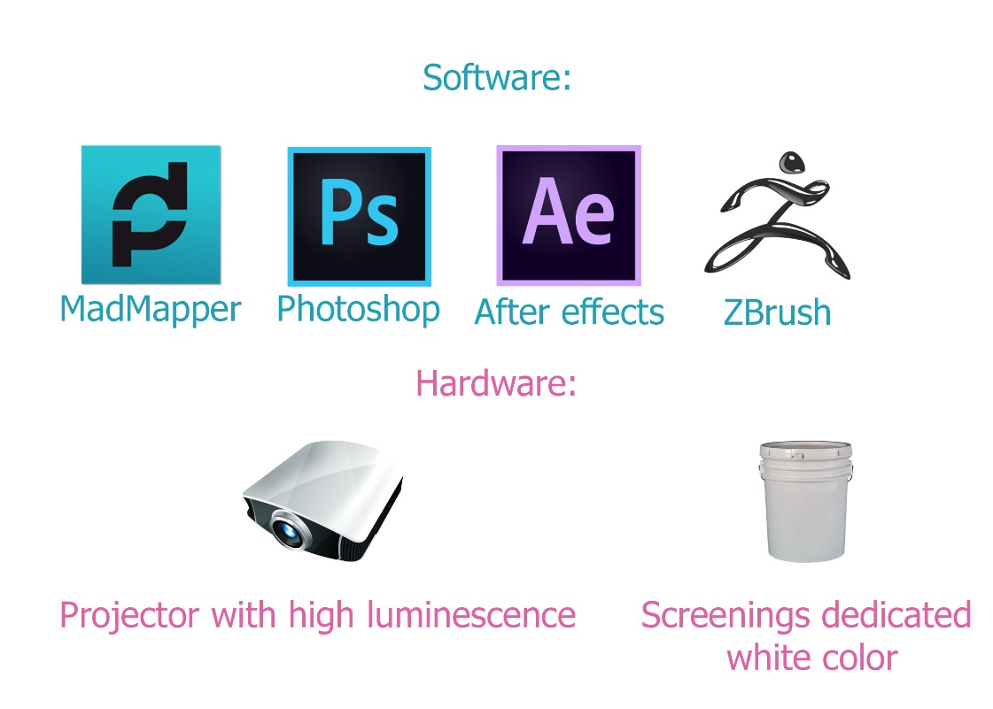

Basic knowledge in video editing is also required.

Create the design

Step 1: Create a low-polygon-count version of the 3D Model

For UV mapping extraction, we need to create a new version of the model. This version will be the same model that was printed, but with a low polygon count. Also, if the model was split for printing into several parts, it is important now to merge it and extract the UV-map from a single model only.

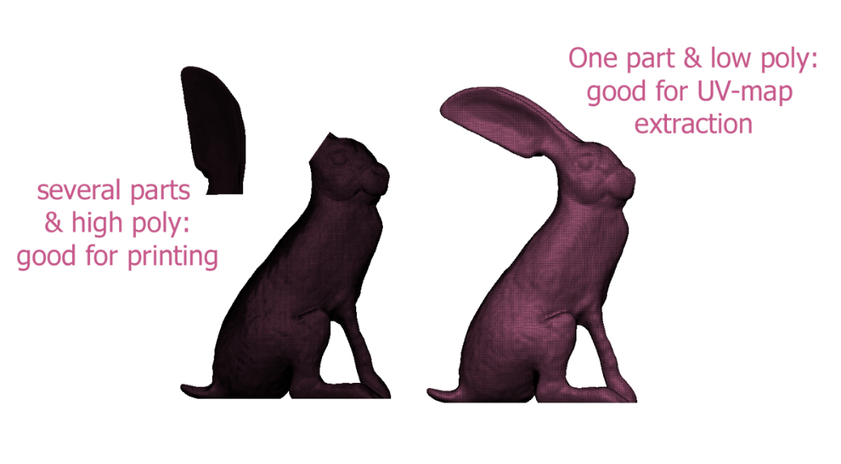

If we want to display different videos, for different regions of the model, it is best to create UV islands.

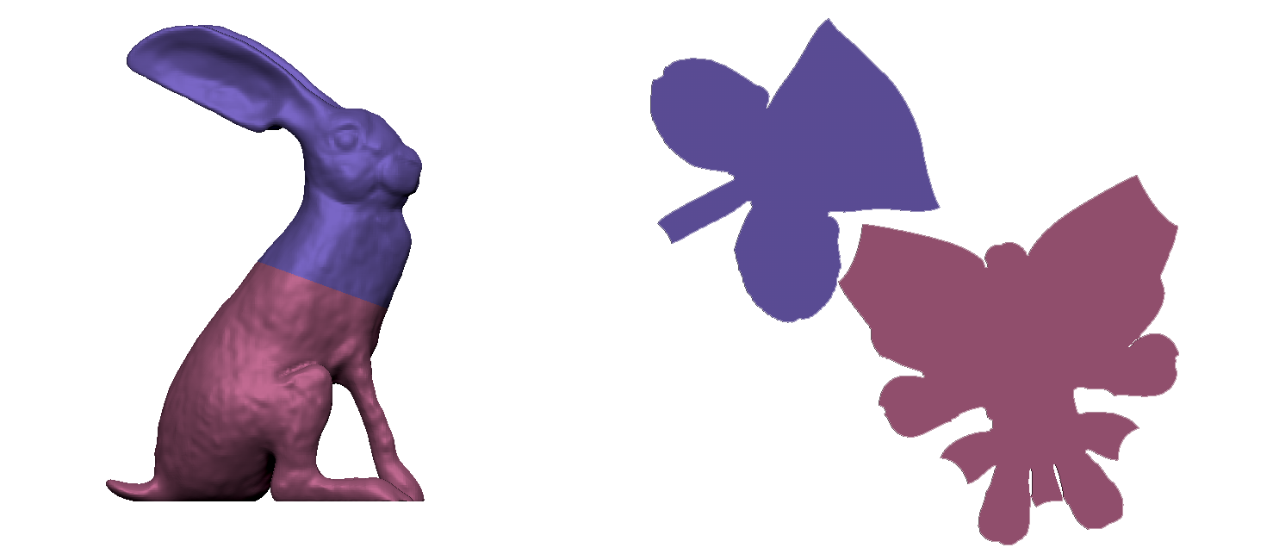

In Zbrush, a UV island can be created using polygongroups on the model, and marking “polygongroups” while we do the unwrap.

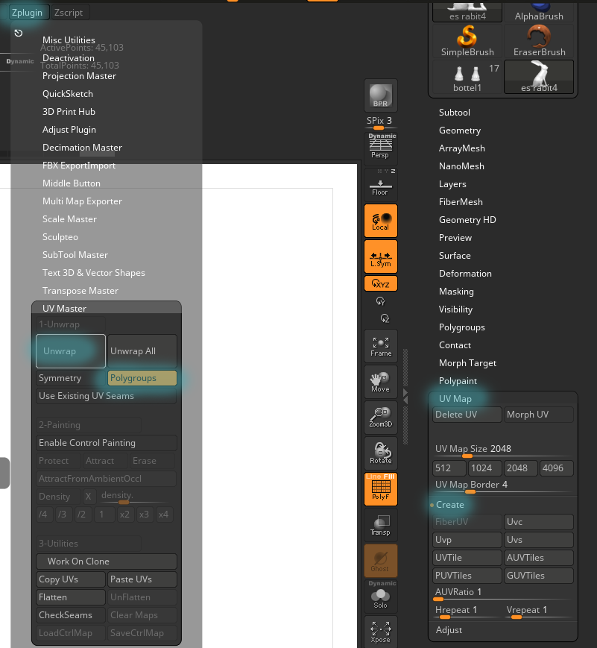

**Note** You can see a 5-minute video tutorial on UV mapping in Zbrush, at the official site: http://pixologic.com/zclassroom/lesson/polygongroups-uv-master

Step 2: Use UV maps as a positioning guide

First create a UV map for the model. As discussed, for multiple texture projections, be sure to create multiple UV islands.

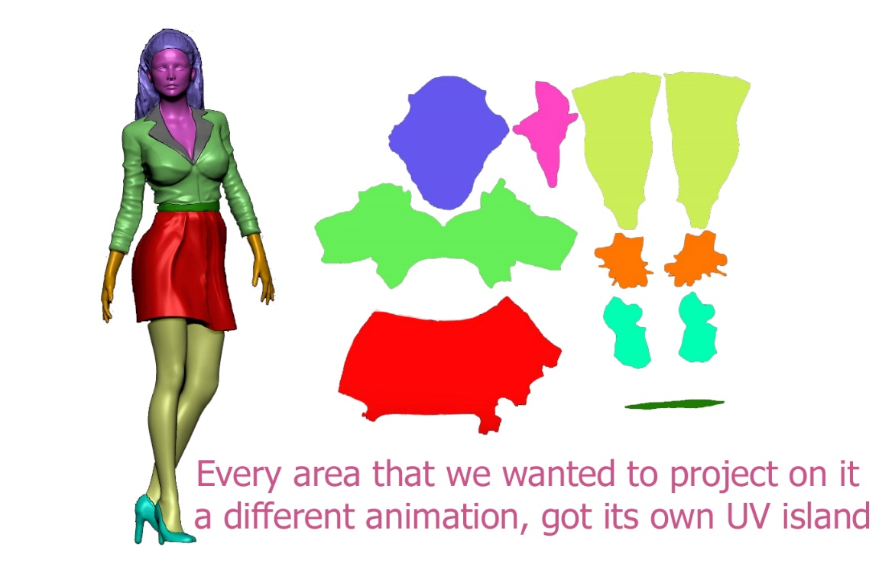

After creating the UV map, export it to Photoshop. Do this by creating a “Texture map” from the existing UV map.

1. In Polygonpaint, go to **Texture map> Create> New**.
2. Press **Clone Txtr**

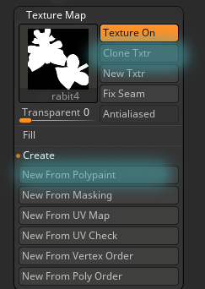

The map will go to the texture pallet on the right side of the screen.

1. From this menu, can export it to Photoshop as a PSD file

**Quick tip**: Save all your files in one folder (3D model, Video files & the Madmapper project)

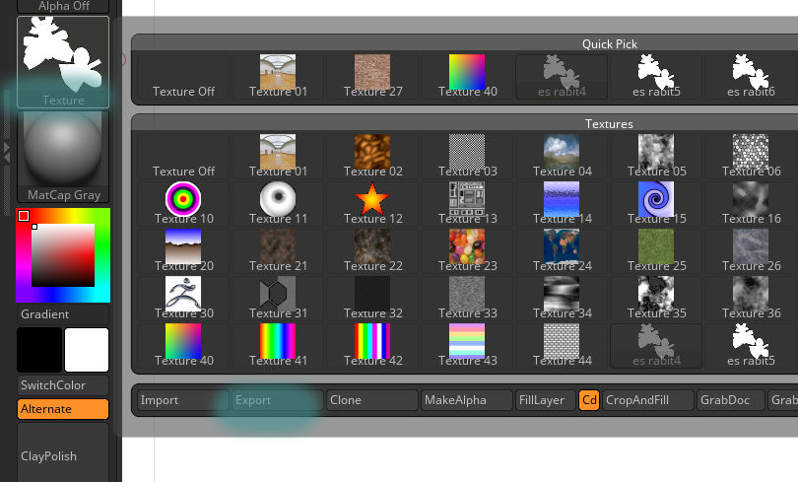

1. Open the file in Photoshop, and create a mask layer from the UV Map.
2. Export the image in a format that includes the Transparency/Alpha channel (PNG, TIFF, etc.).

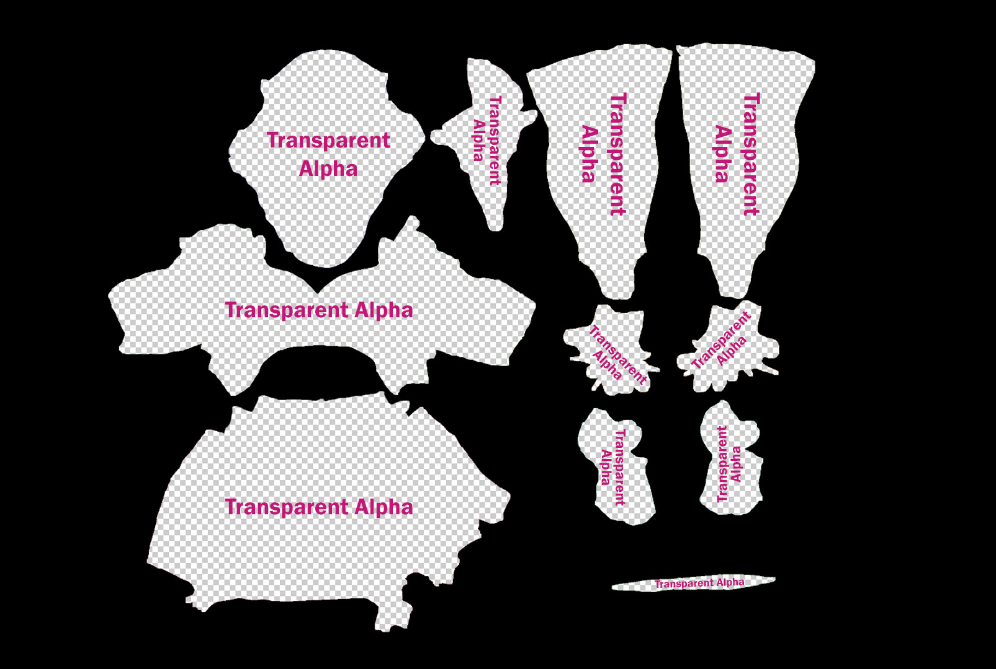

The masked file is used in the video editing project as a transparent layer as top layer. It acts as a mask for positioning your video content to the different parts of your 3D model. When you are finished positioning the map and editing your video texture, export the video file. For best results, use uncompressed AVI or MOV formats. These video formats create large files but play at optimal performance, since there is little or no decoding required.

Step 3: Edit the video

In After Effects, we will edit the video to fit and rely on the transparent texture we exported from Photoshop.

This is done by importing the PNG/TIEF file, and then adding the videos below it. In this way, we will have a perfect correlation between the video and the UV texture map.

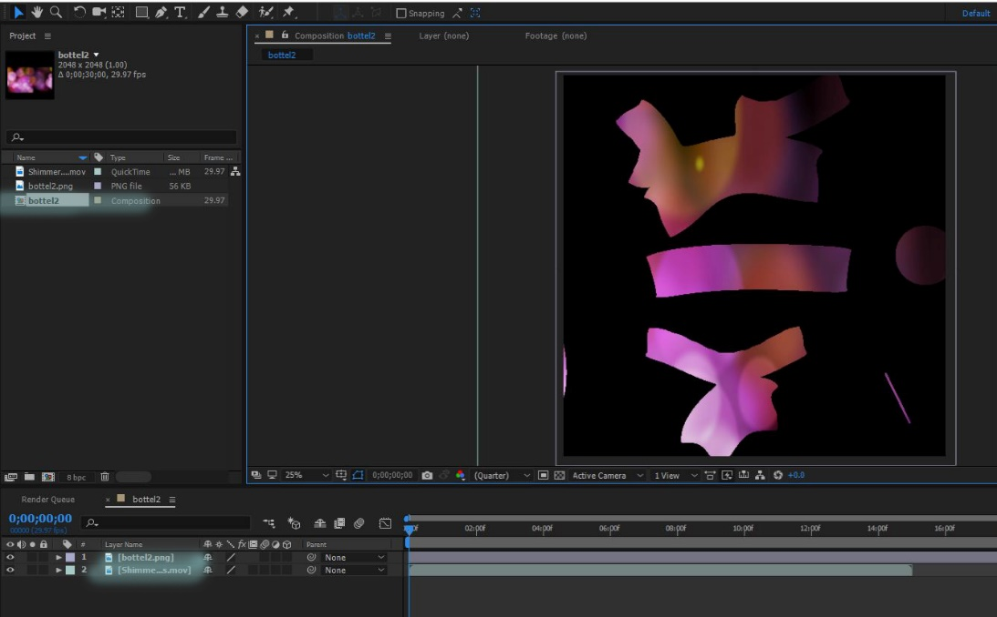

Step 4: Import 3D models and video texture into *Madmapper*

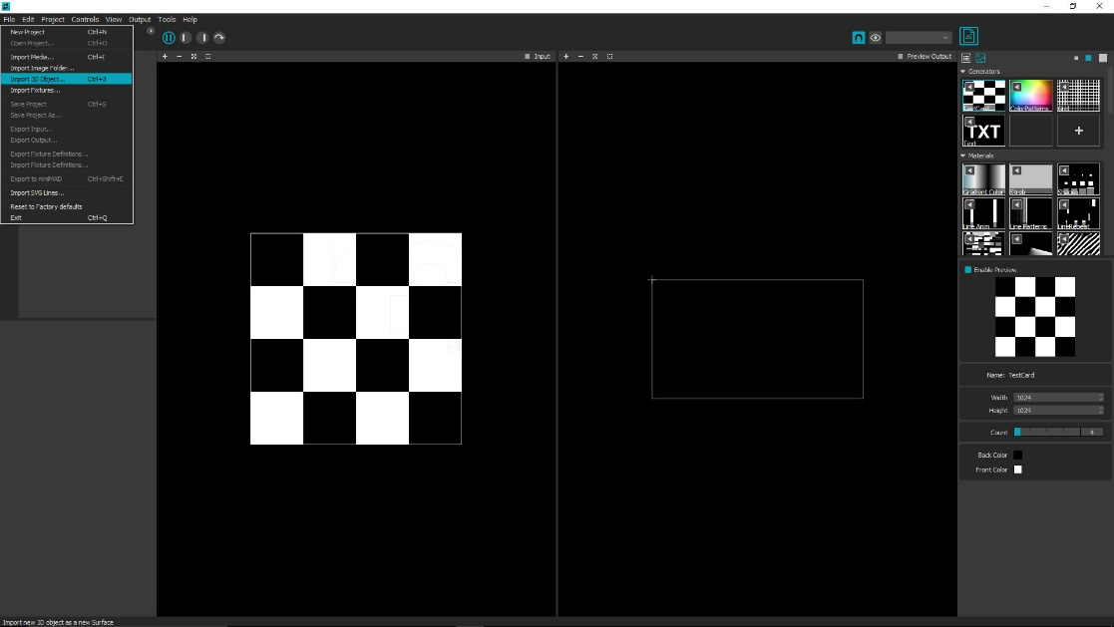

1. Start Madmapper.
2. Click on the **File**, and open the OBJ file (the low polygon version we used for the UV map).  
   The initial screen should look like this:

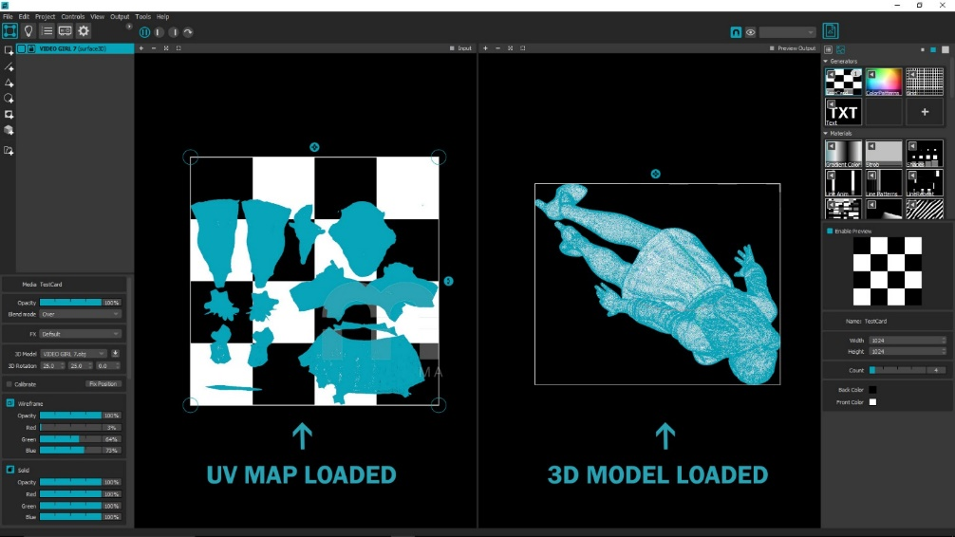

1. Click **File**>**Import media**, and select the UV Video texture from its location on your device.
2. Click **Open**.
3. Scroll to the movies list on the menu on the right.
4. Right-click on the icon of the movie you have imported.
5. Click **Apply** media to selected surfaces. Your video file should line up with the UV map.

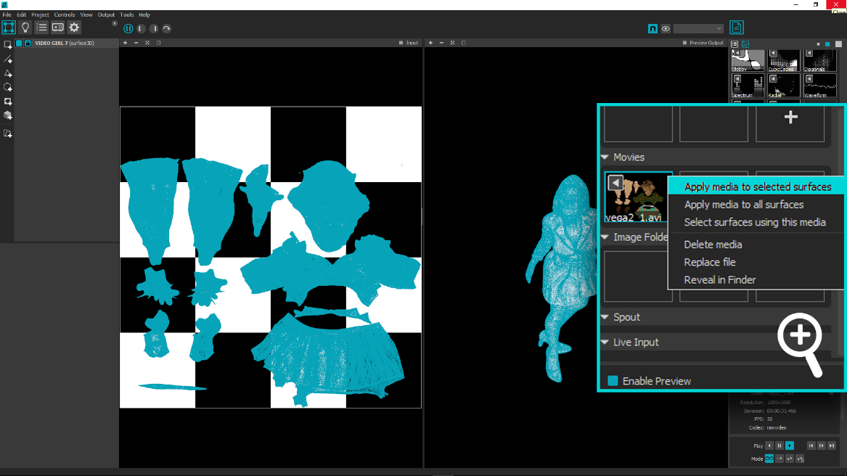

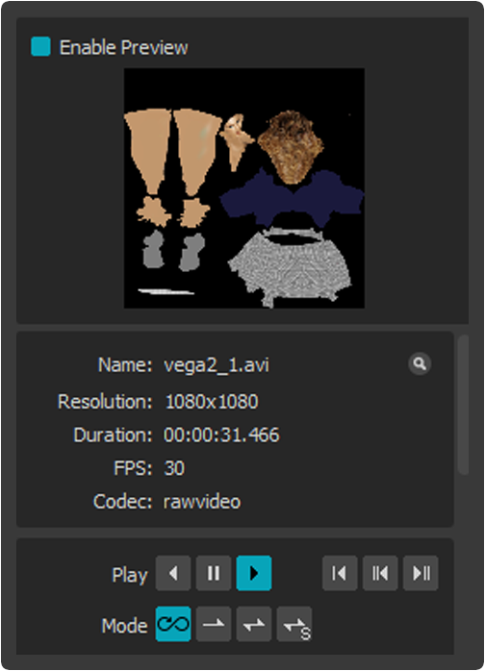

**Quick Tip:** In the media controller, you can play the video forward, backward, pause, and toggle the loop settings.

Step 5: Create a projection

Click the output dropdown and enter **Full Screen Mode.**

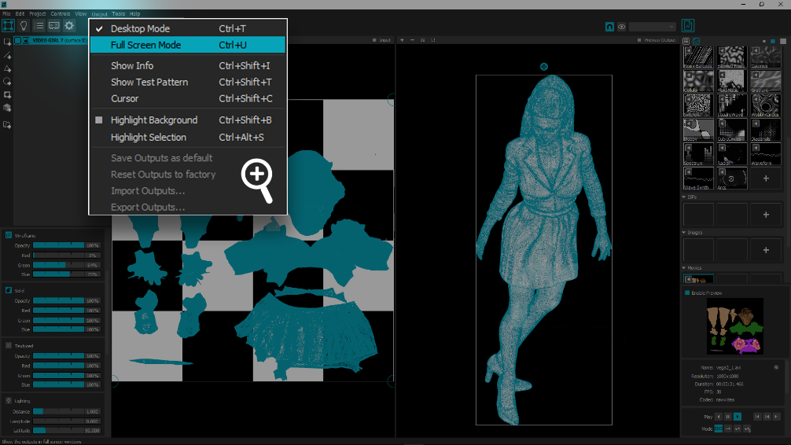

**Note**: At this point, the projector should display your 3D model in the same way as shown on the right side of the screen .

Step 6: Set up the projection, prior to calibration

Adjust the model’s projection scale and orientation to roughly match the 3D object you want to map. Place the model’s projection next to the 3D object, as illustrated in the diagram below. Do not attempt to place the projection on the 3D object at this stage.

These controls adjust the projection:

* Left-click and drag the gizmos to scale and rotate the projection.
* Left-click inside the white outline to move the projected models position in any direction.
* Middle-click and drag to change the position of the view only, without changing the position of the projected model.

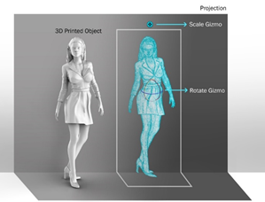

Step 7: Projection Mapping Calibration

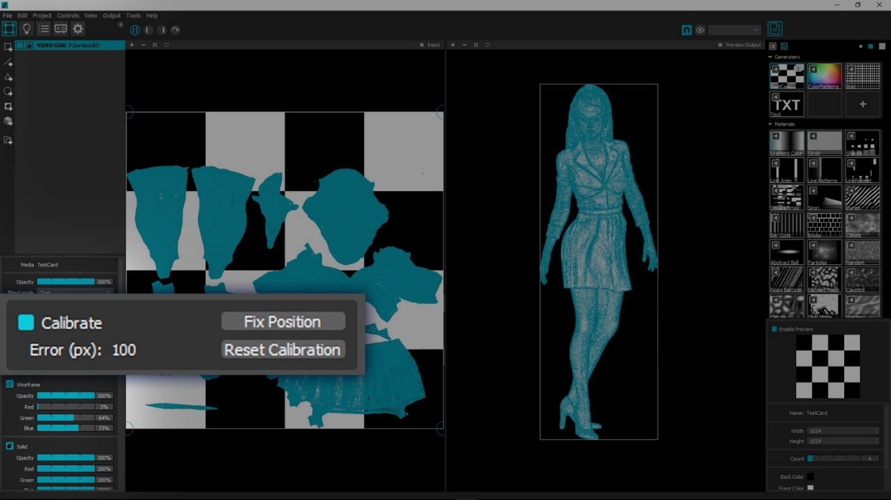

Left-click to activate the **Calibrate** button in the menu on the bottom left side, to initiate the calibration process.

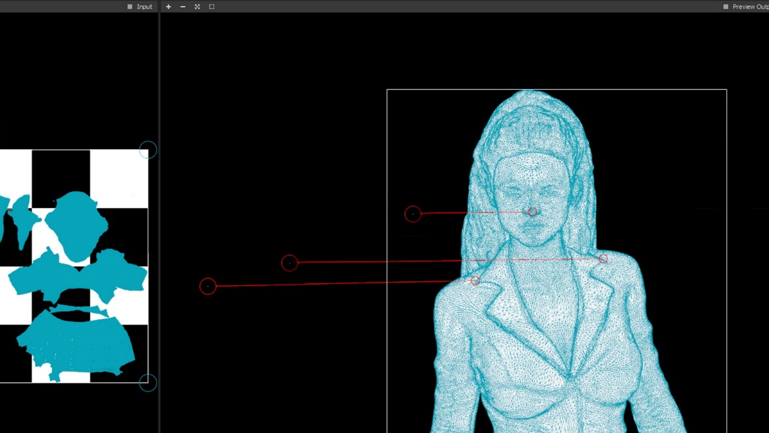

In this stage, you will align the points of the projection and the printed object. This will help Madmapper triangulate and remove distortion from the projection picture, to best match the physical object. At the end of this process, Madmapper will wrap the video texture onto the 3D object. For best results spread out as much as possible the points you select. Try to think in measures such as top left, top right, bottom left, bottom right, and so forth. (In some models, such as the one in the diagram above, thinking like this might be tricky.)

**Quick Tip:** ,pressing By doing this,

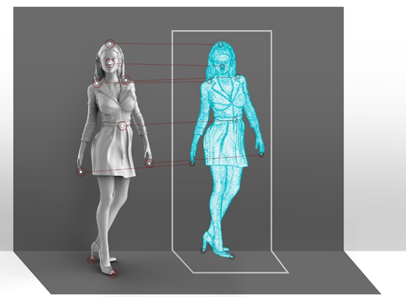

Use these controls:

* While hovering over the 3D model the cursor will change into a circle and snap along the mesh of the object.
* Left-click a point on the model and drag to a correlating point on the 3D Printed object.
* Accuracy is key in this stage, match the white dot in the center as accurately as possible. Pick points on the model that you can easily recognize on the object. Working this way will help you minimize the margin of error.

1. Points can be edited, repositioned or deleted after placement by simply dragging the points to a different position, or by clicking them and deleting by pressing the Backspace on the keyboard.
2. Place and match six points. After this, Madmapper, will auto-wrap the printed object. If for some reason this does not occur, check the accuracy of the point in relation to the object points.
3. Most projections will need more than six points to accurately wrap an object. You can continue matching different points after the initial auto-wrapping process to fine-tune your projection mapping.
4. When you are satisfied with the results click **Fix Position** in the calibrate menu. You can always edit your calibration by clicking **Edit calibration**.
5. Click **File>** **Save Project as** to save your project.

Step 8: Apply the video texture & adding effects

1. Click the **Textured** button on the menu on the bottom left side of the screen to turn the video texture on.
2. On the bottom left menu, there are a few built-in effects that can help refine the overall look of your display. Click any of these buttons to activate the effect, and then set the parameters to your liking.
3. It is recommended to work in wireframe mode while setting calibration. This is the reason that solid & wireframe modes are the default when loading a 3D model.

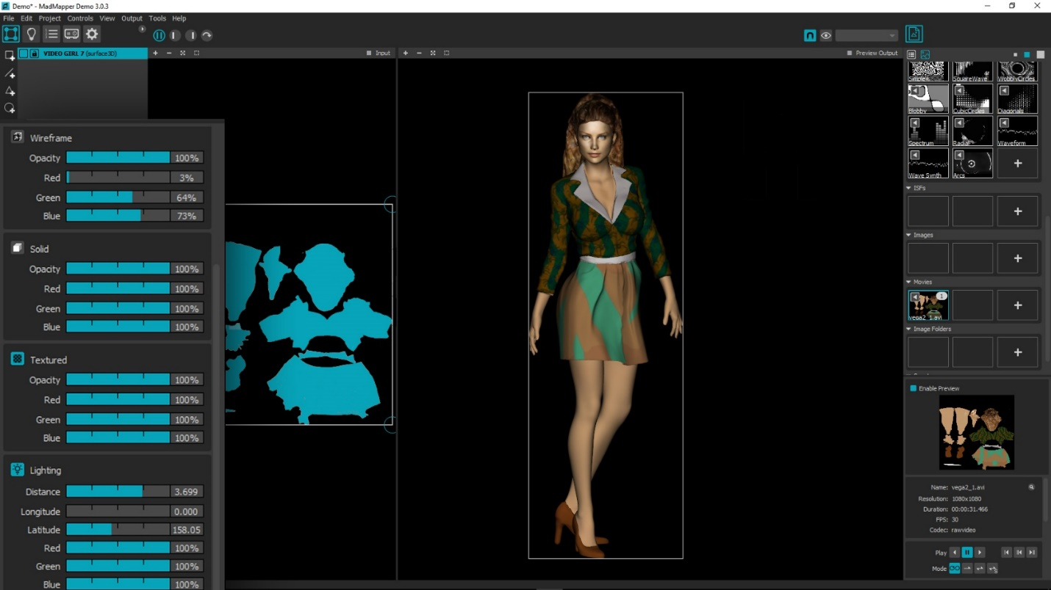

**Note**: **C,**M.

1. Adjust the lighting to give extra depth or to create a dramatic flair for your lighting project.

Workflow Summary

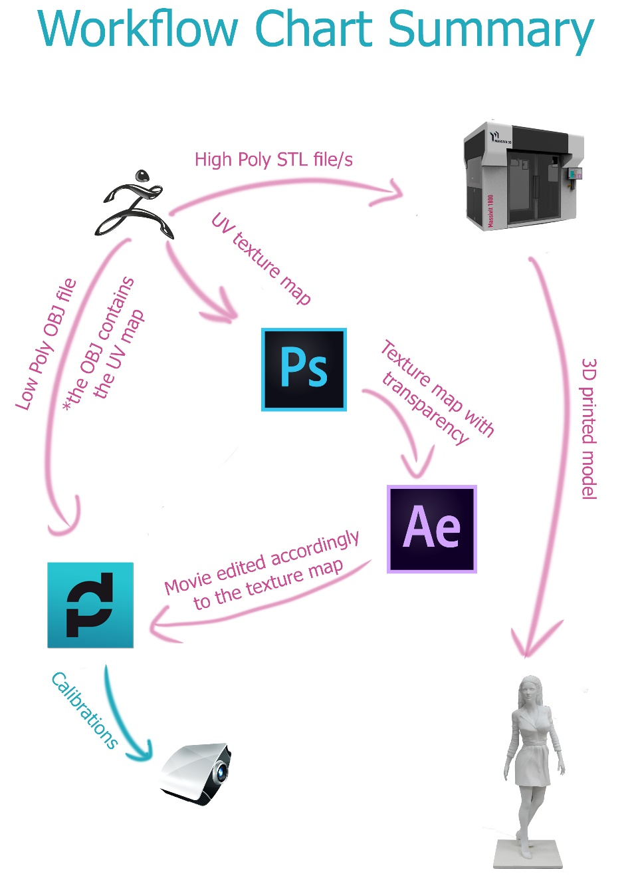

Projection mapping can be a great solution for adding texture, color and motion to your 3D displays. The advantage of printing in 3D for this purpose lies in the fact that UV maps are created from the original 3D file. When the Massivit 3D print is done, the projection mapping process is ready to go in a few simple steps.

The combination of Massivit 3D printers and Madmapper software offers a simple solution for creating complex eye- popping displays with endless possibilities.

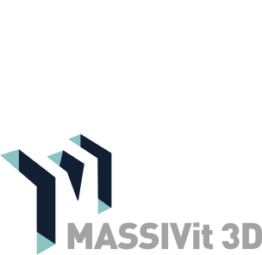

11 Pesah Lev St., Lod 712936. Israel | Tel: +972-8-6519486 | Fax: +972-8-6900758

[www.massivit.com](http://www.massivit.com) | [info@massivit.com](mailto:info@massivit.com)

© 2018 Massivit 3D Printing Technologies Ltd. All rights reserved. Massivit 3D, GDP Gel Dispensing Printing, Massivit 1800 and the related logos and slogans are trademarks of Massivit 3D Printing Technologies Ltd. All brand names are the property of their respective owners and may or may not be trademarked.